**VECTR v6.2.0 Feature Breakdown**

Table of Contents

Reporting Shortcuts and Short URL Support 2

Markdown Editor in Test Cases 6

# Reporting Shortcuts and Short URL Support

What is it?

VECTR now supports saving reporting views which can be accessed through a quick launch menu.

How does it work?

From the reporting screen, create a reporting screen that you want to save.

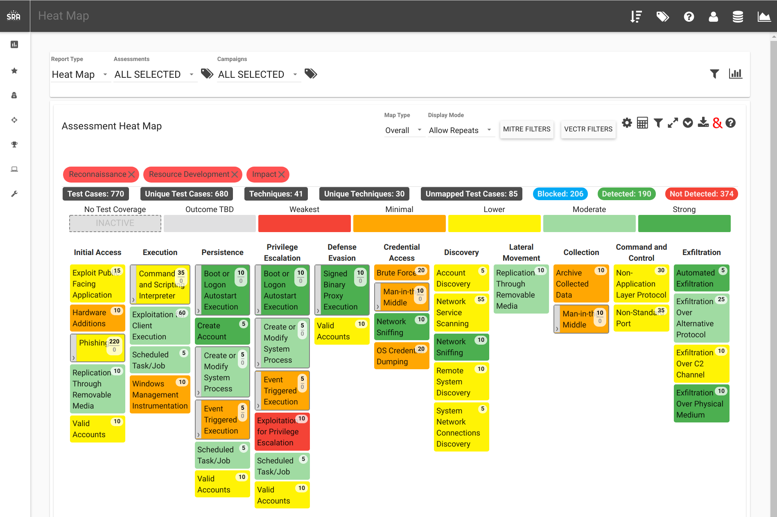

In the top right, click the “Manage Report Shortcuts” icon:

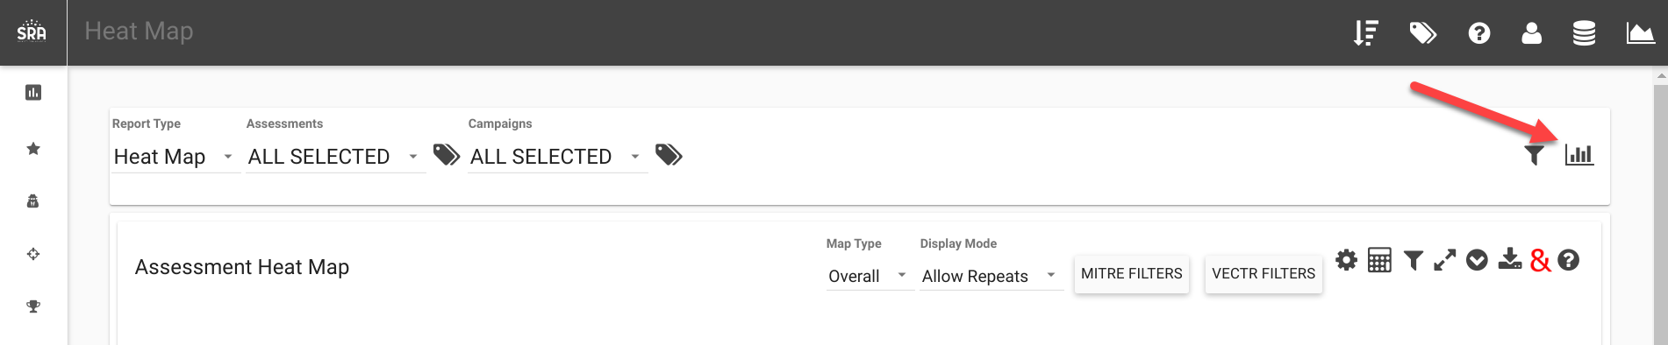

Click “Create New”:

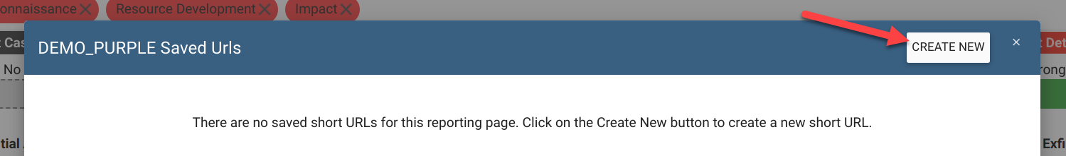

Fill out the Name and Description fields, then click submit.  
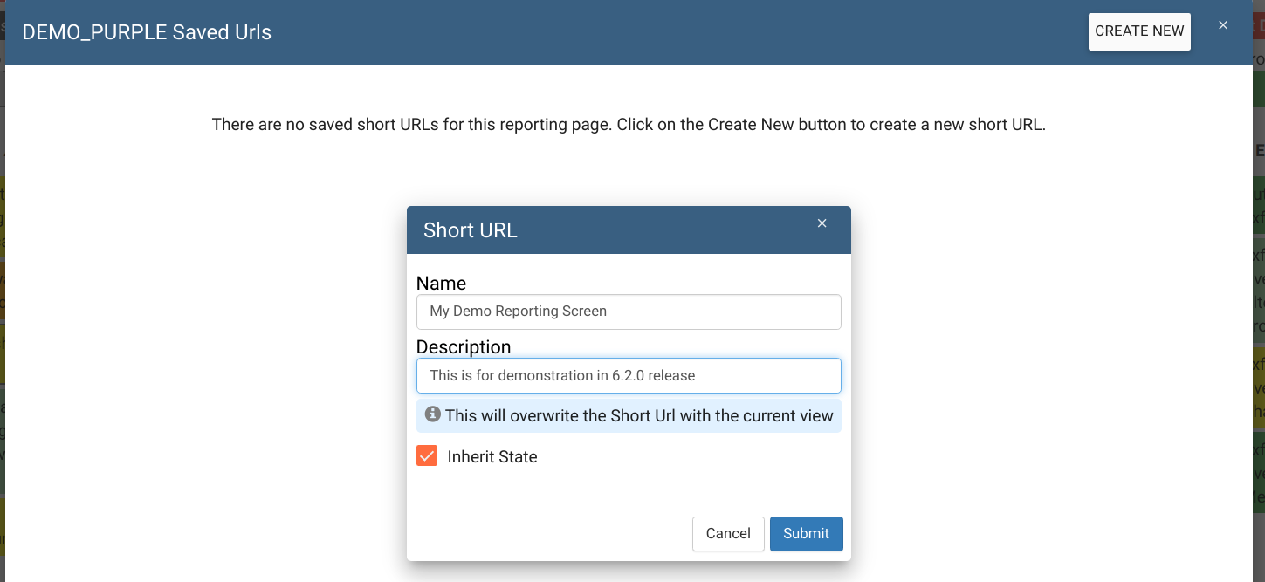

After the shortcut is generated, they are accessible from anywhere in the app through the Global Report Shortcuts button:

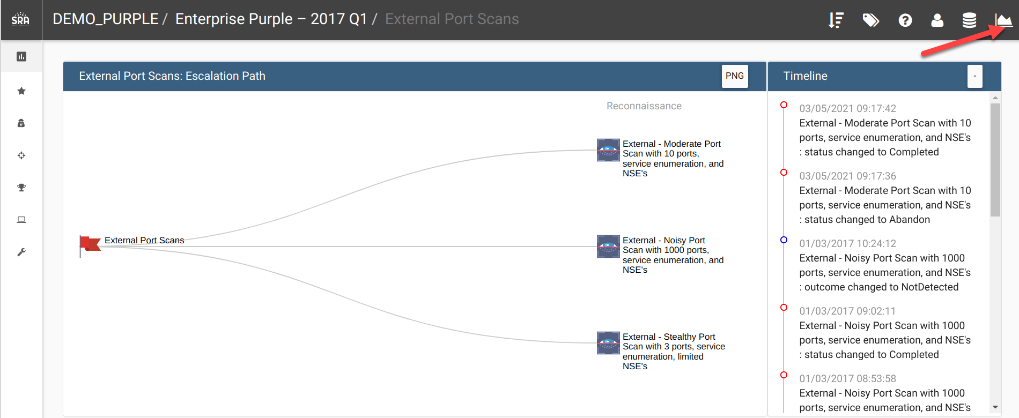

This will bring up the saved URLs in all databases. Clicking the “Load” button will take you to the saved reporting screen:

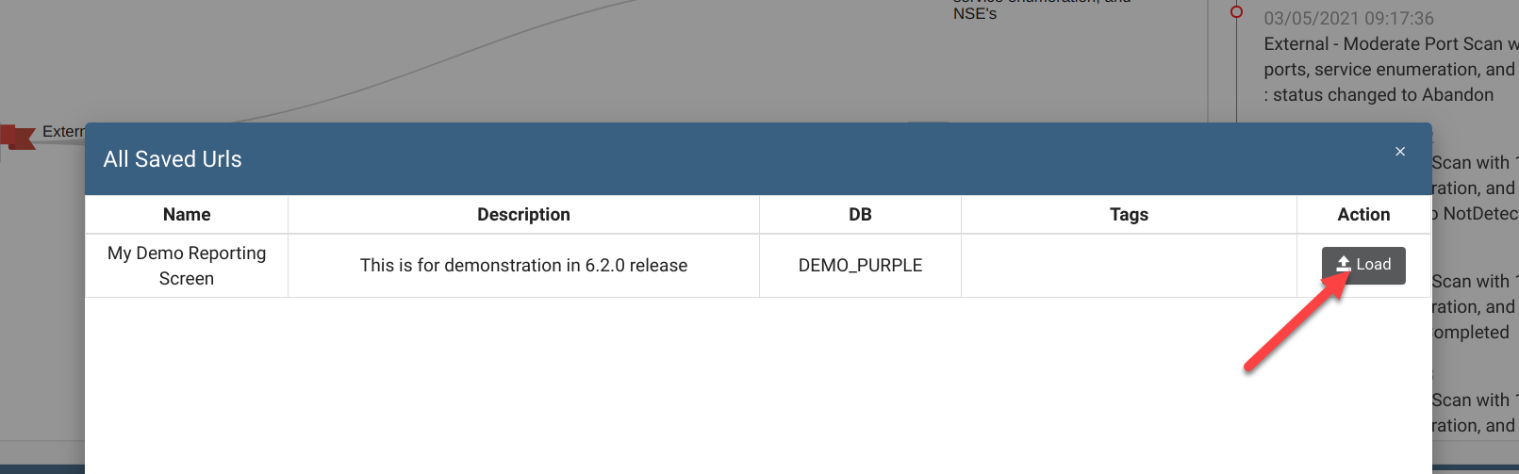

The Global Report Shortcuts is just for loading reporting screens and spans all databases. The management of the shortcuts is done in the reporting screen though the Manage Report Shortcuts, and only allows you to edit URLs in your currently selected database.

For example, if you wanted to change the reporting screen associated with the shortcut, you would click the Manage Report Shortcuts icon, followed by the ‘Edit’ Button:

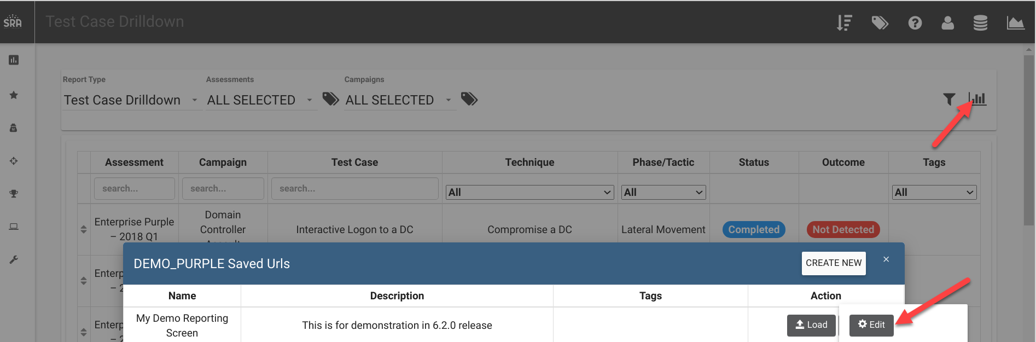

Clicking “Inherit State” will override the saved reporting screen with the current screen you have displayed. In this example, I want to replace the “Heatmap” view with the “Test Case Drilldown” View:

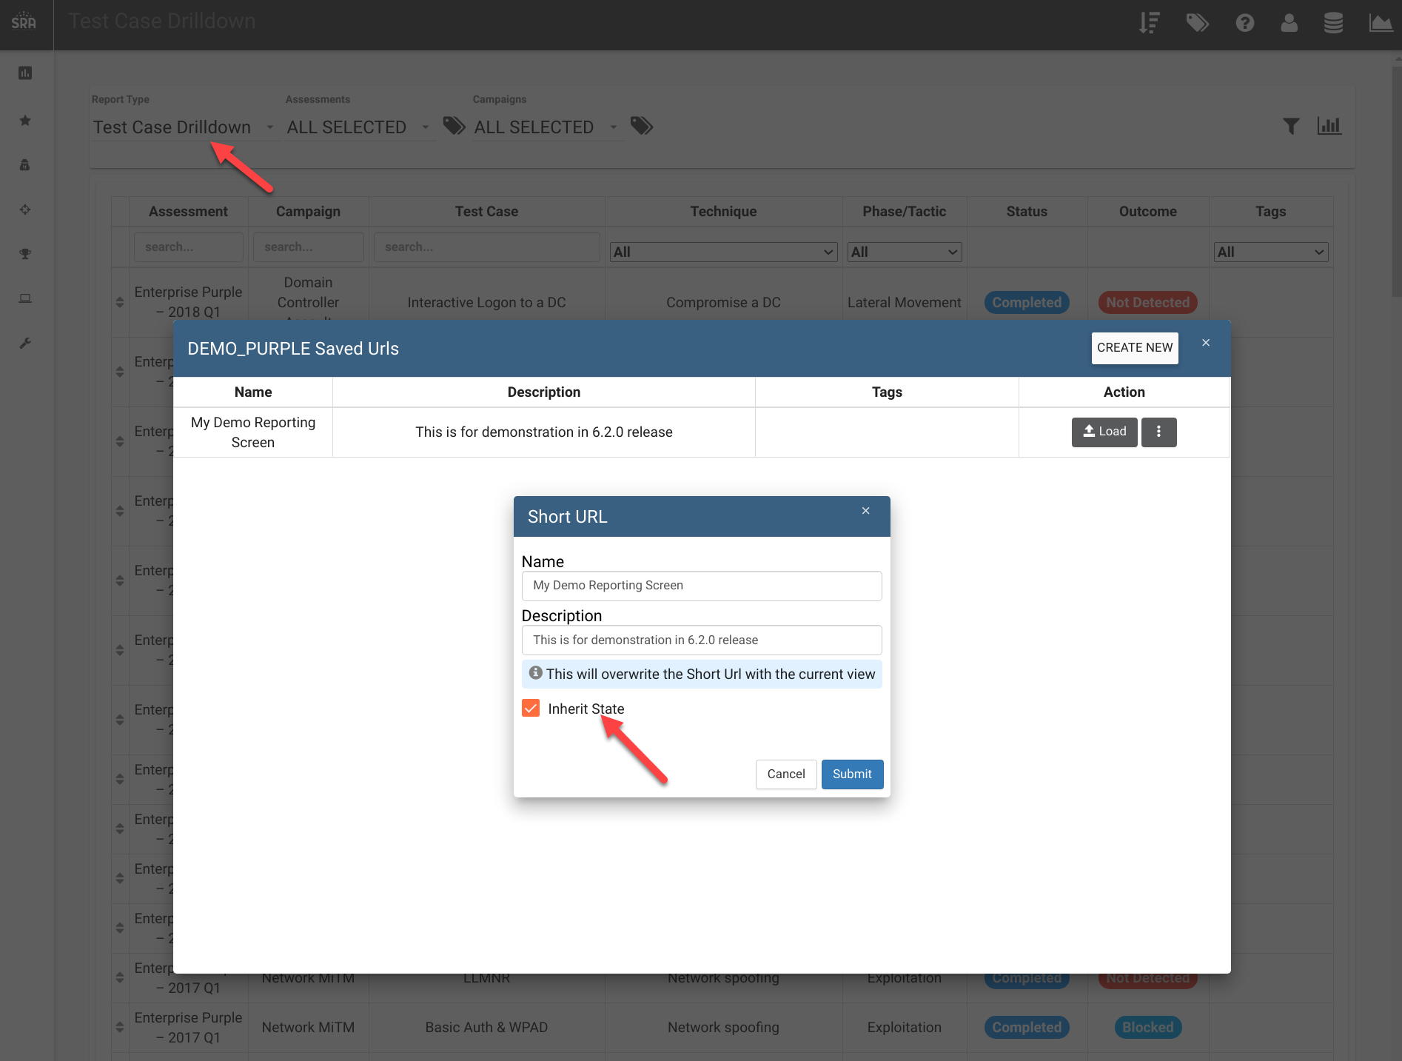

If you just wanted to change the name or description without changing the underlying view, leave the “Inherit State” unchecked.

How can this feature help me?

Allow for fast access of commonly used reporting screens.

# Markdown Editor in Test Cases

What is it?

You can now use Markdown syntax in Description, Operator Guidance, and Outcome Notes in the Test Case panel.

How does it work?

Click on “Edit” mode of the panel. This will let you use Markdown syntax. Clicking “View” will show you the preview:

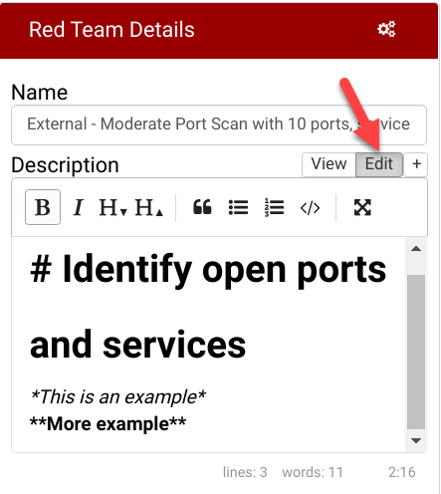 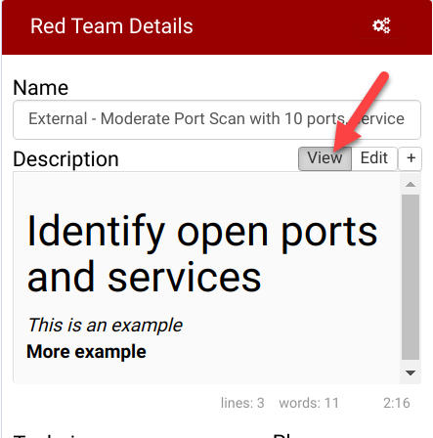

How can this feature help me?

This will allow users to format text to provide more context in their notes.